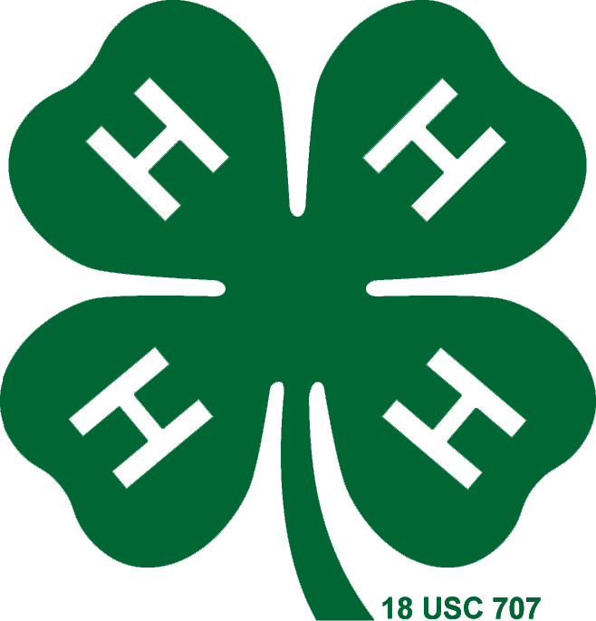

San Bruno/SSF General Meeting Agenda

September 14, 2016

**Call to Order:**

**Pledge and Flag Salute**

**President’s Notes**

**Treasurer’s Report**

**Secretary’s Report**

**Farm Report**

**Community Leader Report**

**Old Business:**

* Fair Recap
* 4-H Camp
* Fundraising Efforts
  + Fair Cake Booth
  + Flea Market
  + Garage Sale
* Record Books

**Program:**

* New Board Member Introductions

**New Business:**

* *Important Dates*
  + County Council Meeting September 26th 7pm
  + Farm Clean Up September 17th 10-3
  + Open House September 18th 1pm
* Updated Website/ New Google Calendar Link
* Enrollment/Farm Rules for the County
* Foosball Table Announcement/Rules
* Sweatshirt 4-H (Project Sweatshirt for Animal Projects)
* Bee Project Decision

**Announcements**

* Birthdays